* First I approached the problem by defining the step size and the direction of the steps and assigning it to a variable. I used arrays to create the data for further use. I have calculated PDF by using the built-in Kernel Density function in the numpy library. Once assured by seeing the output values I plotted the Probability density vs position curve for a single case.

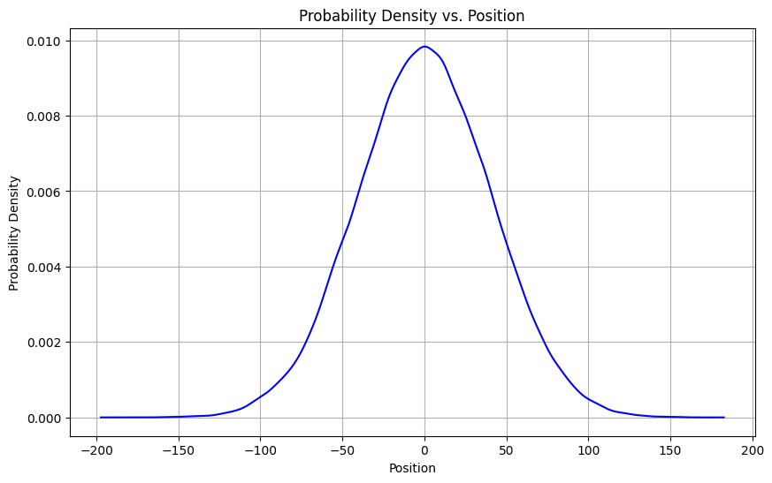

* Then I simulated the case of different population sizes and plotted them. I was very happy to see that they actually behave the same for various population sizes.

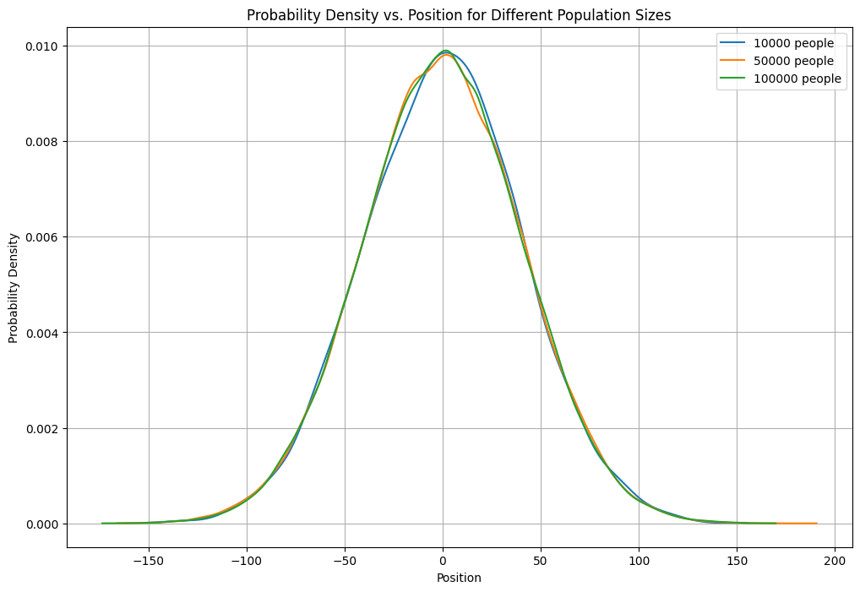

* Then I varied the step numbers keeping the population size intact. Immediately I saw that the FWHM increased as well as the maximum probability decreased with the increasing step numbers.

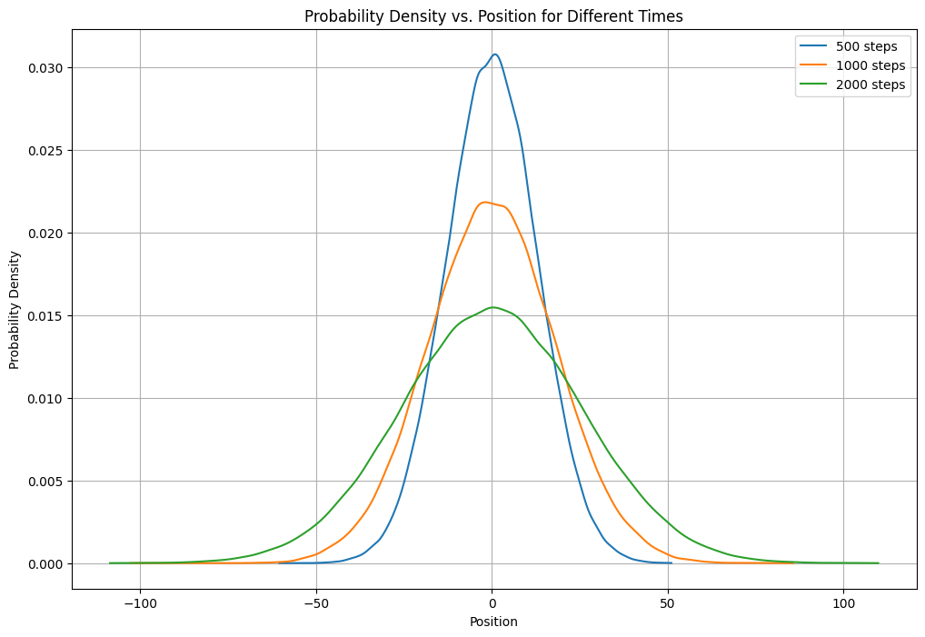

* Then I multiplied the probability density with the square root of step numbers. The peak of the dimensionless pdf vs positions merged nearly at the same point.

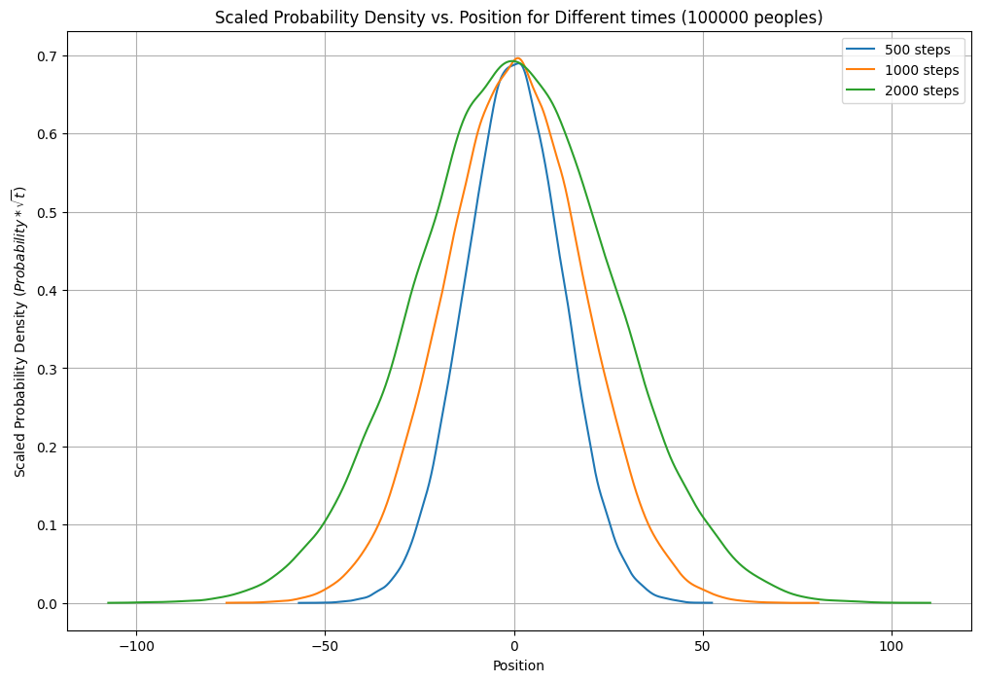

* Lastly I divided the position by the square root of step numbers and the plot showed that all the curves merge in one curve.

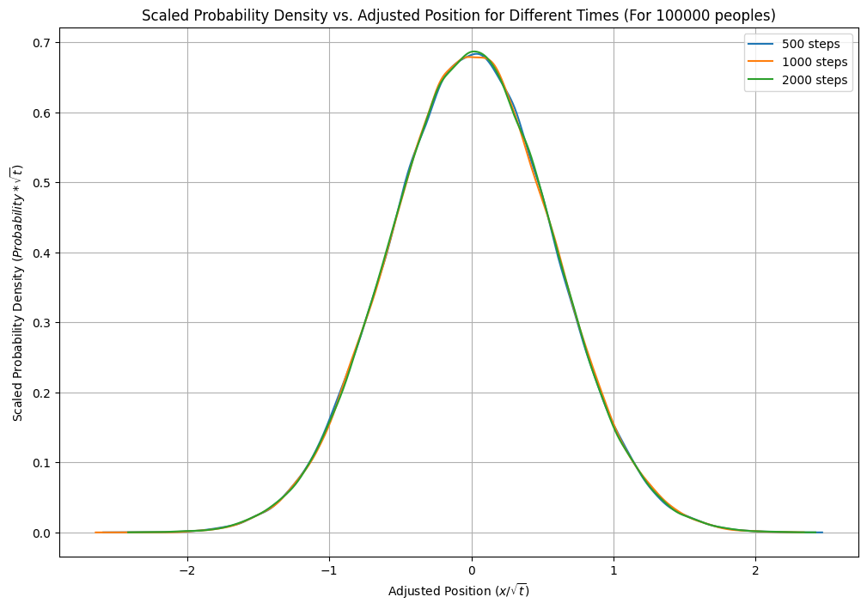

* The log(maximum probability) vs log(times) curve exactly shows a straight line with slope -½ as you said in class.

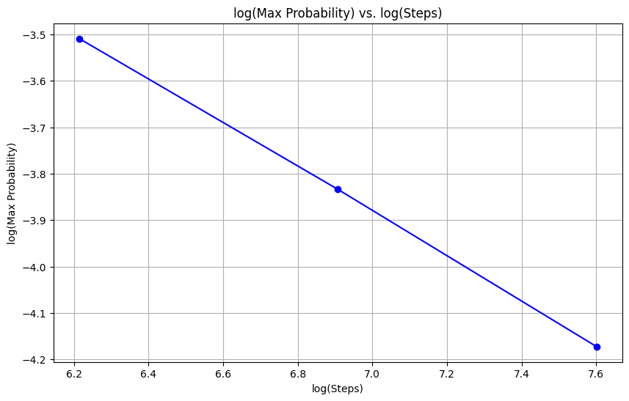

* I, being motivated by the image shown in your class, tried to make a visualization of the random walks in a graph by showing every step of each person. That also showed up like a Gaussian distribution.

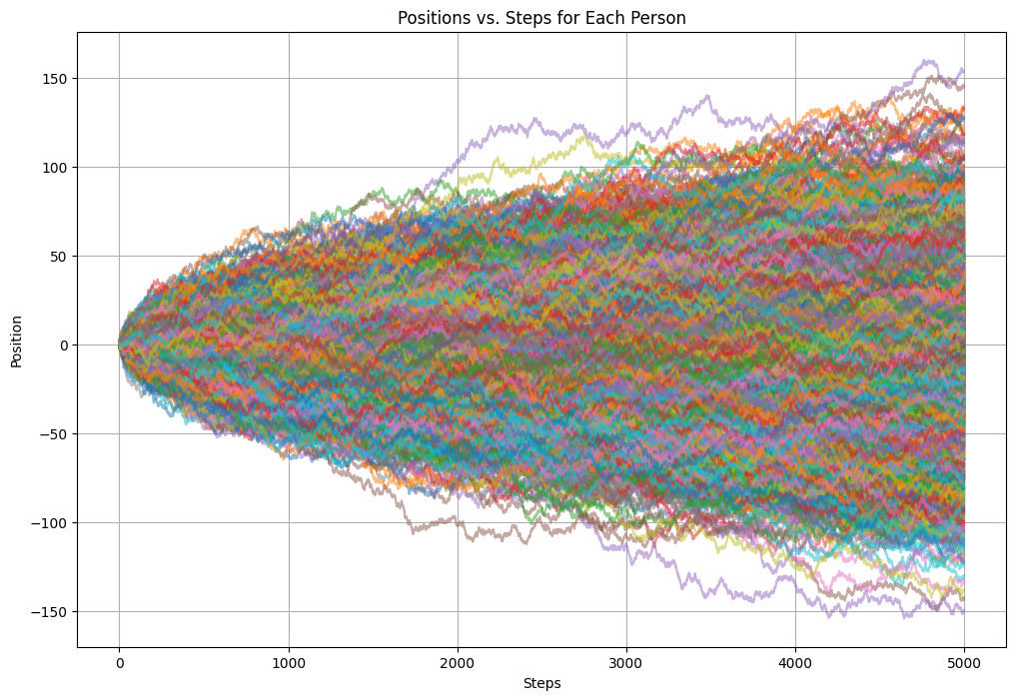

**Codes:** All the codes are stored in this Google Drive link as a Google Colaboratory file.

<https://colab.research.google.com/drive/1pyUZ5UIsP7ZZcPef5s5r4o3_VB34XixU?usp=sharing>

**Acknowledgement**: I got a lot of help from Proshanto. Also, I took a little help from chatgpt to draw the colorful graphs and for labeling.